HOW TO MAP TO NETWORK SHARE DRIVE for Windows
NOTE: SAS can ONLY install on Win 7, 8.1 Pro or Ultimate version.
There are 3 factors you would need to access department share drive
- VPN Client – Creating secure tunnel to connect to University resources
- The path - where the resource located
- User : A valid user name and password
How to get VPN?
To download VPN, you can go to: http://it.umn.edu/downloads-guides. Make you select appropriate platform version for your operating system. After you downloaded the VPN, follow the installation instruction below:
- In Program FilesCiscoCisco AnyConnection Secure Client. Make sure you type: tc-vpn-1.umn.edu (as shown) Connect.
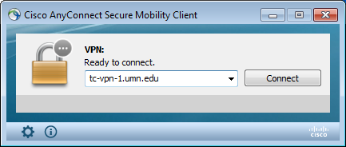

In Group, select option as shown below. Type your x500 user name and password.

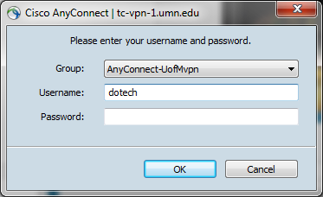
After Cisco connected, you are ready to map to your network share drive.
StartComputer (Right Click)Map Network Drive (shown below)
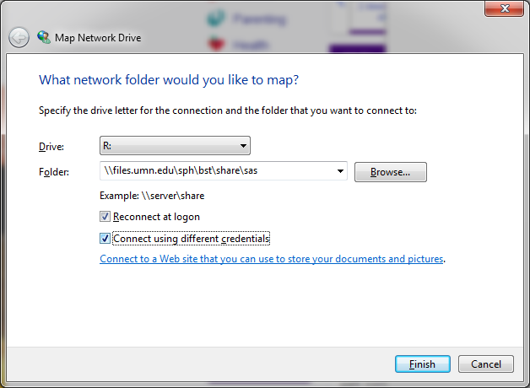
In Drive, you can just use default letter.
In Folder, type the path as showing.
Connect Using Different Credentials show be check marked as showing Finish.
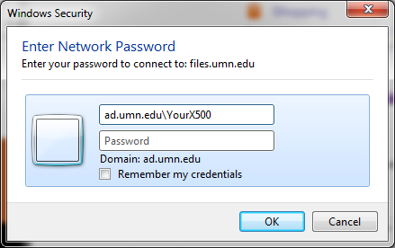
Type in your University X500 as shown above and passwordok.
Congratulation. You are now connecting to SAS 9.4. Just open either folder and look for setup.exe to install. I strongly recommend you copy down to your local drive (C: drive) before install. If you choose to install it directly, allow yourself at least about an hour.

