Application Form
The RESEARCH Applied Epidemiology Training Program provides training for the next generation of researchers dedicated to ensuring positive weight-related health among young people and families from diverse communities. The program offers training to predoctoral (PhD) and postdoctoral fellows.

Instructions:
Please complete this form and submit it along with the supporting documents listed below. All application
materials should be sent to the program email address REACH-T32@umn.edu. Two letters of recommendation should also be submitted by your references in separate messages to REACHT32@umn.edu. Application materials include:
- Curriculum vitae
- Graduate School Transcripts
- Sample publication or writing sample (for example, a paper, manuscript, funding proposal or other professional document first-authored by the applicant)

- Name: Click or tap here to enter text.

- Address: Click or tap here to enter text.
City, State, Zip: Click or tap here to enter text.
Research on Eating and Activity for Community Health
Applied Epidemiology Training Program

- Telephone: Click or tap here to enter text.

- Email: Click or tap here to enter text.

- Availability date: Click or tap here to enter text.

- Education: (Please attach copies of your college transcripts. Official copies are preferred but not
required.)
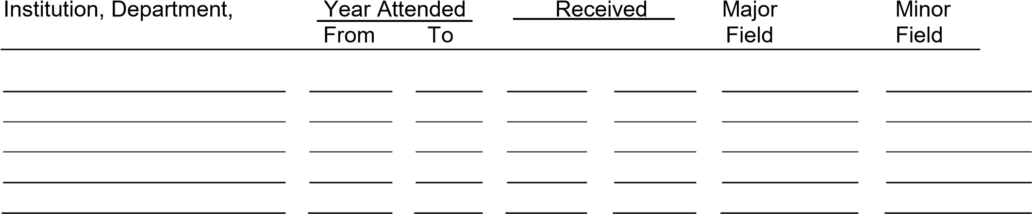and Location Degree Mo.& Yr.

- Professional experience: (Please attach a copy of your curriculum vitae.)
Dates Job Title Brief Description Employer .
(MM/Yr)

- Other relevant experience:
Click or tap here to enter text.

- Scholarly contributions: [Attach 1) list of publications and presentations; 2) publication/writing sample.]
Click or tap here to enter text.

- If you are applying for a Predoctoral Fellowship, please indicate the status of your Graduate Program acceptance:
    - Admitted or current student
    - Admissible pending identification of advisor
3Unknown
- If you are applying for a Postdoctoral Fellowship, please provide the following information:
  - Thesis research topic and/or other research topic (if relevant):
Click or tap here to enter text.
  - Research advisor: Click or tap here to enter text.

- Briefly describe your research interests relating to the promotion of healthy eating and physical activity (250 words or less).
Click or tap here to enter text.

- Briefly describe your research interests relating to youth and families from diverse communities (250 words or less).
Click or tap here to enter text.

- Briefly describe your research career goals and how do you see this research training contributing to these goals (250 words or less).
Click or tap here to enter text.

- We are interested in promoting a training atmosphere, institute, and society that is devoted to diversity, equity, inclusion, and anti-racism. Please share your thoughts on how you will contribute to the promotion of these principles (250 words or less).
Click or tap here to enter text.

- Please list the names, title, and organization of those references you have requested:
Name Title Organization

- Mentor Preferences: [Indicate your preference for primary and co-mentor(s). See the list of program faculty on the training program website (https://z.umn.edu/REACHT32). Final mentor selection will be made by the Program Director, but trainee preference will be taken into account.]
    - Primary Mentor from Program Faculty: Click or tap here to enter text.
    - Co-Mentor from Program Faculty: Click or tap here to enter text.
    - Co-Mentor from Program Faculty: Click or tap here to enter text.

Research on Eating and Activity for Community Health Applied Epidemiology Training Program
(This request for confidential information will allow us to fulfill NIH reporting requirements)

- Gender:
Male Female Other, please specify: Click or tap here to enter text.
Do not wish to answer

- Pronouns:

He/him She/her They/them Other, please specify: Click or tap here to enter text.

Do not wish to answer

- Citizenship:
U.S. Citizen or Noncitizen National

Non-U.S. Citizen
With a Permanent U.S. Resident Visa (“Green Card”)
With a Temporary U.S. Visa
If not a U.S. citizen, of which country are you a citizen? Click or tap here to enter text.

- Do you identify as Hispanic or Latino? Yes No Do not wish to answer

- Do you identify as one or more of the following races? Select one or more. American Indian or Alaska Native
Native Hawaiian or other Pacific Islander
Asian
Black or African American
White
Do not wish to answer

- Do you have a disability as defined by the American with Disabilities Act? (https://www.ada.gov/2010_regs.htm)
Yes No Do not wish to answer

- Are you from a disadvantaged background?
(See NIH definition, https://extramural-diversity.nih.gov/diversity-matters/disadvantagedbackgrounds)
Yes No Do not wish to answer

